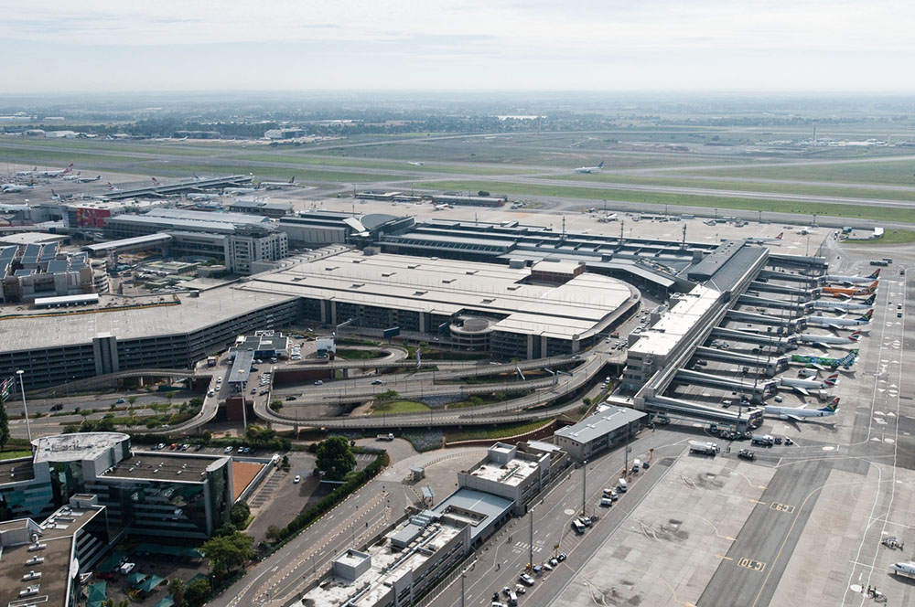

Byron Leukemans Grade 12

*MAPPING THE SUSTAINABLE SKIES IN SOUTH AFRICAN AVIATION*

**PAT 2024**

Flight to the future



Table of Contents

Structure of PAT: 1

Introduction to the PAT 2

Task Definition 3

What is the current situation? 5

What is the Focus and Purpose of this investigation? 5

How will I go about the investigation, considering the requirements? 5

Who is the target audience? 5

Focus Question 6

Discussion and Analysis: 7

Summaries 9

Findings 22

Conclusion 23

Bibliography 24

Appendix A: Table 25

Appendix C: Authenticity 32

### 

### Table of Figures

Figure 1 Structure of assessment. 1

Figure 2 Image of aviation pioneer, Emilia Earhart 2

Figure 3 Airlines operating with SAF (Sustainable Aviation Fuel) to South Africa 5

Figure 4 Noise pollution at Pietermaritzburg Intl (ICAO: FAPM) 6

Figure 5 Feedstock for alternative fuel in South Africa 6

Figure 7 Biofuel value chain from its source to end-use. 10

Figure 8 Combustion of jet fuel in Sub Saharan Africa, taken from the RSB report. 11

Figure 9 Why should we pursue in SAF production in transport? 11

Figure 10 SAF workshop 2023, discussing the ways forward. 13

Figure 11 Estimation on net-zero carbon by 2050, according to the RSB report. 14

Figure 12 Socio- economic impacts from the domestic SAF industry. 21

Figure 6 Image of greener fuel loaded into plane (Boeing 737) 24

# Structure of PAT:

This task critically examines the various ideas created by individuals to create a safer and better sky, resulting in a more economical aviation sector, that will benefit the generations to come.

Figure 1 Structure of assessment.

# 

# Introduction to the PAT

I

magine a future where the skies are not just blue, but also green. Welcome to the dawn of a new era in aviation, where the pursuit of flight meets the call of sustainability, not just to the environment, but also the creation of available jobs. “The engine is the heart of an airplane, but the pilot is its soul.” As aviation pioneers like Amelia Earhart once envisioned the boundless possibilities of flight, today we stand on the brink of a new chapter, where the roar of engines is accompanied by the whisper of innovative progress. From electric dreams soaring silently overhead to jets powered by nature’s own fuels. The aviation industry is embarking on a transformative journey towards a greener tomorrow. Join us as we shall explore the cutting-edge technologies, innovative solutions, and bold initiatives propelling aviation towards a more eco-conscious future, where the thrill of flight harmonises seamlessly with our commitment to the planet. Fasten your seatbelts, because the journey to greener skies is about to take off, not only on a national scale, but international as well!

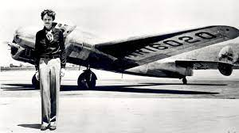

Figure 2 Image of aviation pioneer, Emilia Earhart

# Task Definition

The aviation industry is in a constant state of evolution, experiencing rapid changes and advancements on an annual basis. In response to this dynamic landscape, prominent aeronautical companies such as Boeing and Airbus continually innovate and unveil designs that shape the trajectory of the next generation of aviation. This evolution is not only driven by technological progress but also by the imperative to address environmental concerns and enhance sustainability within the industry.

According to data from [www.carbonindependent.org](https://ujac-my.sharepoint.com/personal/shaunl_uj_ac_za/Documents/www.carbonindependent.org), the environmental impact of aviation is substantial, with even widely used aircraft such as the Boeing 737-400 burning an average of 90kg of CO2 per hour. This figure becomes even more daunting when considering the sheer volume of flights taking place simultaneously. Furthermore, larger aircraft like the Boeing 747 have an even greater environmental footprint, consuming approximately 8.4 metric tonnes of CO2 per hour, as reported by [www.goldenpaulettes.com](http://www.goldenpaulettes.com). (on page 11)

Understanding the magnitude of these environmental implications is crucial for shaping the future of aviation in a sustainable manner. It is imperative to assess not only the technological innovations driving the industry forward but also the environmental consequences of these advancements. By examining data on the total number of flights tracked on [www.flightradar24.com](https://ujac-my.sharepoint.com/personal/shaunl_uj_ac_za/Documents/www.flightradar24.com), (**Error! Bookmark not defined.**) we can gain insights into the scale of aviation activity and its corresponding environmental impact.

Considering these considerations, the task at hand is to delve deeper into the intersection of technological innovation, environmental sustainability, and the future of aviation. This investigation aims to analyse the current state of the aviation industry, identify key challenges and opportunities related to sustainability, and propose actionable strategies for mitigating environmental impact while advancing the next generation of flight.

Through rigorous research, data analysis, and stakeholder engagement, this task seeks to provide comprehensive insights and recommendations that can inform decision-making within the aviation sector. By addressing the environmental challenges inherent in aviation and embracing sustainable practices, the industry can chart a course towards a more environmentally responsible and resilient future.

## What is the current situation?

Currently, there is a pressing need to address environmental sustainability in the transportation sector, including aviation, due to its significant contribution to carbon emissions and environmental degradation. In South Africa, the aviation industry is a vital component of the transportation sector, connecting the country domestically and internationally. However, like many other countries, the aviation industry in South Africa faces challenges related to environmental sustainability, including carbon emissions, noise pollution, and resource consumption.

## What is the Focus and Purpose of this investigation?

The focus of my investigation will be to assess why pursuing a green job in the aviation industry in South Africa is a promising endeavour compared to other sectors in transport concerning environmental sustainability. I aim to explore the specific initiatives, technologies, and policies within the South African aviation industry that promote environmental sustainability and make it an attractive option for individuals seeking green careers. The purpose is to provide insights into the potential opportunities and challenges associated with pursuing green jobs in the South African aviation sector and to offer recommendations for individuals interested in this field.

## How will I go about the investigation, considering the requirements?

I will conduct thorough research using a combination of scholarly sources, industry reports, government publications, and interviews with relevant stakeholders. I will analyse data and case studies to draw insights and conclusions regarding the viability and desirability of pursuing green jobs in the South African aviation sector compared to other transport sectors.

## Who is the target audience?

The target audience for this report includes policymakers, government agencies, aviation industry professionals, environmental organizations, academic researchers, students, and individuals interested in pursuing careers aligned with environmental sustainability within the aviation sector in South Africa.

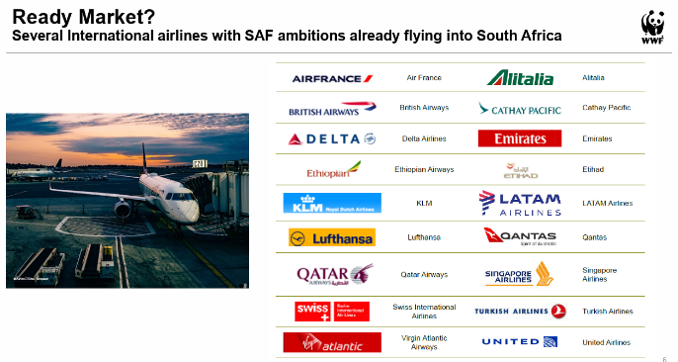

Figure 3 Airlines operating with SAF (Sustainable Aviation Fuel) to South Africa

# Focus Question

What strategies can the South African aviation industry implement to achieve a strong balance between technological innovation and environmental sustainability now and for years to come by enabling green job sustainability?

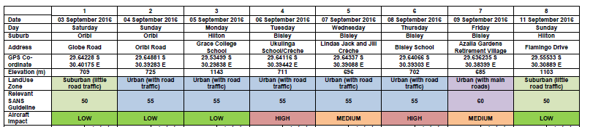

Figure 4 Noise pollution at Pietermaritzburg Intl (ICAO: FAPM)

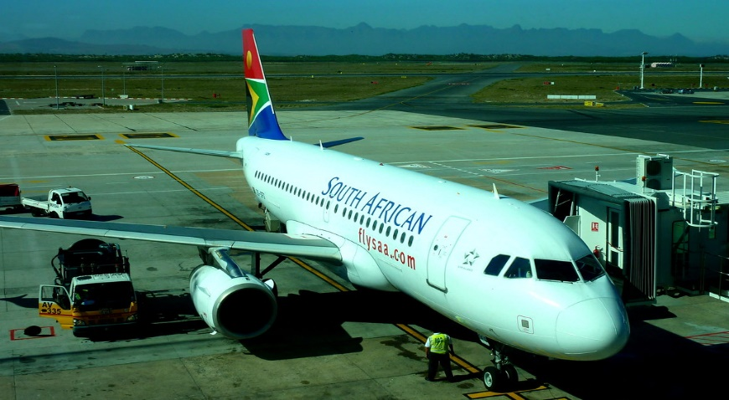

[This Photo](https://www.flickr.com/photos/air_traveller/13634944523/) by Unknown Author is licensed under [CC BY](https://creativecommons.org/licenses/by/3.0/)

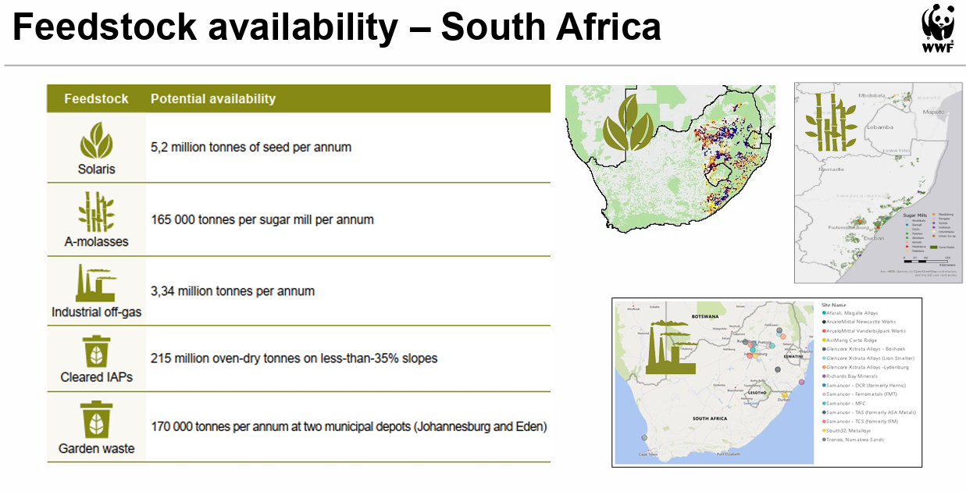

Figure 5 Feedstock for alternative fuel in South Africa

# Discussion and Analysis:

After thorough research and summarisation through various mentioned sources, it is evident that the South African skies are becoming increasingly safer and more sustainable, as predicted by SAA the fuel efficiency of airplanes have reduced by 1.5%, and a target of 50% reduction of CO2 emissions by 2050 (9), however through the help of international companies, the RSB/SAF being one of them has noted the national goal of reducing emissions and also now being partners with South Africa, by providing our country with sustainable jet fuel, this fuel consists of organic material that his grown right here in South Africa. Furthermore, the Parliament of South Africa has come up with regulations on restricting noise pollution in major areas (17), this is beneficial as this gives the skies less noise and more air quality. Through these regulations, many South African engineering companies have taken the initiative to create a fuel tank that uses hydrogen to supply the aircraft with sustainable fuel, which also provides less noise in the skies in South Africa (14)

As seen in the graph provided it is evident that 53% of individuals are aware of green jobs in the aviation sector, whereas 47% is unaware, this could be because people are not kept up to date with the latest news about aviation, also another factor could be due to the fact that this sector does not openly share information to the public.

It is evident that 57% of individuals are aware of the increasing of job opportunities in this sector, which is quite mesmerising as it indicates that this sector is constantly expanding, leading to the need of staff.

Furthermore, it is evident that 60% of individuals would consider a job in this sector, this is spectacular as it indicates that this industry will have some competitive advantages over other sectors. Also, it is exciting to note that individuals are willing to work in a sector that is constantly changing, this could be due to the impact of 4IR.

 To view my findings, please click on the the Excel icon

# Summaries

### 1.What are the current aviation emissions in South Africa, and how do they compare to other sectors?

According to a recent post on [www.flysaa.com](http://www.flysaa.com) conducted in 2020, it is mentioned that “South African Airways aims to conduct their business in the most sustainable way possible”.

They aim to do these ‘activities’ on the environment by continually:

* Minimising waste
* Operating the most energy and water efficient practices
* ‘working’ towards reducing their carbon footprint.
* Striving for the most efficient flight operations

SAA’s main industry goal also states:

* A cap on aviation CO2 emissions from 2020 onwards
* A slight improvement in fuel efficiency of 1.5% per year from 2009 to 2020
* A predicted 50% reduction of CO2 emissions by 2050, relative from 2005

However, the airline assures its patrons by working with various other programmes, such as the IATA Environmental Assessment programme, in which has developed a comprehensive Environmental Management system. Additionally, SAA is one of only 2 IEnvA stage Two certified airlines in the world.

They have also set up with alternative sustainable fuels by collaborating with Boeing, SkyNRG and Sunchem on a pioneering biofuel program by using Solaris tobacco strain (yes, strained tobacco!). this in turn avoids displacing any food crops, supports local communities and delivers cleaner fuels without harming the environment.

Furthermore, SAA's Eco Initiatives:

* Recycling: Onboard waste recycling initiated on domestic routes, lobbying for international recycling.
* Energy Efficiency: Implementing energy-saving measures, aiming for 100% renewable energy for head office.

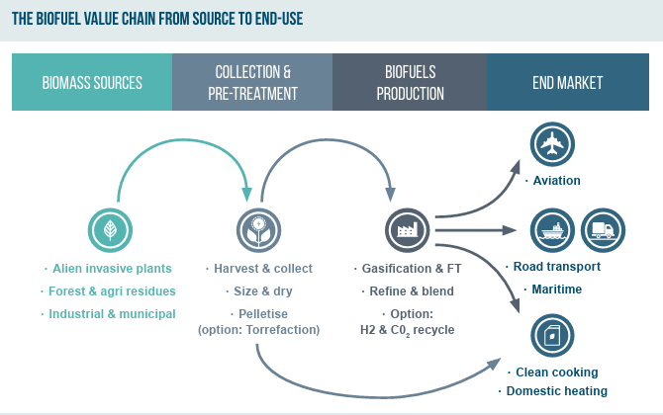

Figure 7 Biofuel value chain from its source to end-use.

* Procurement: Sustainability criteria integrated into procurement to promote eco-friendly products.
* Water Conservation: Investigating water use, collaborating with WWF-SA for conservation programs.
* WWF-SA Partnership: Supporting WWF-SA through Voyager miles donations, participating in conservation programs like SASSI and Biodiversity in Wine Initiative.

### 2.How do South African airlines and airports use renewable energy, what’s the percentage of their energy consumption from this?

According to the RSB/SAF (Sustainable Aviation Fuel), discussed on 21 April 2022, it was seen that:

* Fossil kerosene production is finite and involves various refining processes, with jet fuel combustion contributing over 95% of airline carbon emissions in Southern Africa.
* SAF, a drop-in fuel reduced up to 50% of emissions using conventional jet fuel, which utilizes diverse sources such as waste oils, non-food crops, and even industrial pollution.
* Sustainability certification ensures that SAF feedstock does not compete with food crops or water supplies and reduces overall CO2 emissions by recycling CO2 absorbed during feedstock growth.
* Hydrogen is increasingly important in SAF production, reducing carbon footprints during the refining process.

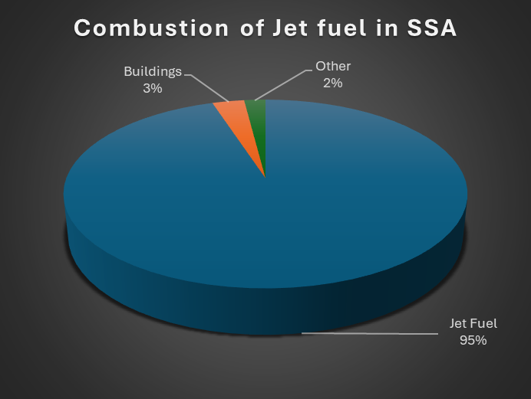

Figure 8 Combustion of jet fuel in Sub Saharan Africa, taken from the RSB report.

* Various certified technologies and pathways, including Hydro processed Esters and Fatty Acids (HEFA) and Fischer-Tropsch, are used for SAF production, with South Africa's Fischer-Tropsch facilities being prominent.
* Blended SAF is distributed to airports and used in existing engines without requiring infrastructure modification.
* Its greenhouse gas emission reduction is calculated throughout its cycle, offering anywhere from 10 to 90% reductions, and supporting aviation's net-zero goals, within Sub-Saharan Africa (SSA).

### 3. What governmental policies drive environmental practices in South Africa?

According to the South African Government of the Transport sector ([www.gov.za](http://www.gov.za)) it summed up that.

* National Environmental Management Act (NEMA): This comprehensive legislation serves as the cornerstone of environmental governance in South Africa. It outlines principles for managing and conserving the environment, promoting sustainable development, and ensuring environmental justice. NEMA establishes institutions and procedures for environmental management, including environmental impact assessments and environmental management plans.

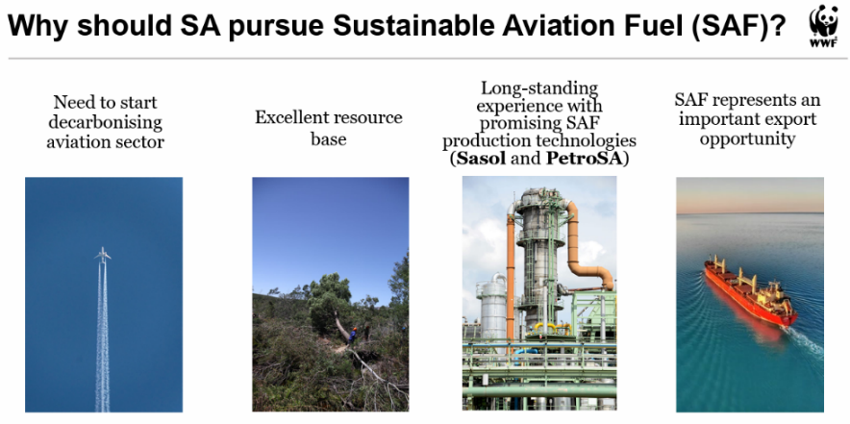

Figure 9 Why should we pursue in SAF production in transport?

* It also provides mechanisms for public participation and enforcement of environmental laws.
* National Environmental Management: Waste Act: The Waste Act aims to minimize the generation of waste and promote environmentally sound waste management practices. It regulates the collection, storage, transportation, treatment, and disposal of waste to prevent pollution and protect human health and the environment. The Act encourages recycling and resource recovery, imposes responsibilities on waste generators and producers, and establishes standards for waste management facilities.
* National Environmental Management: Air Quality Act: This legislation addresses air pollution and its impact on public health and the environment. It sets out air quality standards and emission limits for pollutants, regulates industrial and vehicle emissions, and establishes monitoring and enforcement mechanisms. The Act also requires the development of air quality management plans by national, provincial, and local authorities to improve air quality in designated priority areas.
* National Water Act: The National Water Act provides a framework for the sustainable management of water resources in South Africa. It aims to ensure equitable access to water, promote efficient water use, and protect water quality and aquatic ecosystems. The Act establishes a system for water allocation and permits, regulates activities affecting water resources, and requires the development of catchment management plans. It also recognizes the role of communities and stakeholders in water resource management.
* Renewable Energy Independent Power Producer Procurement Programme (REIPPPP): This program promotes the development of renewable energy projects in South Africa through competitive bidding processes. It seeks to increase the share of renewable energy in the country's energy mix, reduce dependence on fossil fuels, and mitigate greenhouse gas emissions. The REIPPPP provides incentives and support for the development of renewable energy infrastructure, including wind, solar, biomass, and hydroelectric projects.
* Carbon Tax: South Africa implemented a carbon tax in 2019 to mitigate climate change by pricing carbon emissions. The tax applies to entities that emit greenhouse gases above specified thresholds, incentivizing emission reductions and the adoption of cleaner technologies. Revenue generated from the carbon tax is used to support initiatives for climate change adaptation and mitigation, as well as to fund renewable energy projects and environmental conservation efforts.
* Environmental Impact Assessment (EIA) Regulations: These regulations require developers to assess and mitigate the environmental impacts of proposed projects before obtaining approval from authorities. EIAs evaluate the potential environmental, social, and economic   
    
    
  consequences of projects, identify measures to minimize or mitigate adverse impacts, and involve stakeholders in the decision-making process. The EIA process aims to promote sustainable development by ensuring that development activities are environmentally responsible and socially acceptable.

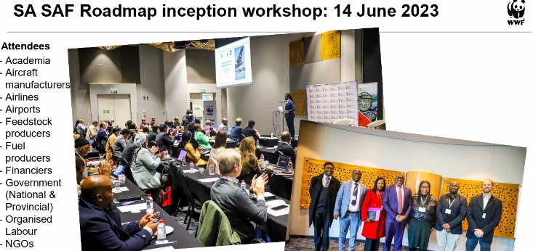

Figure 10 SAF workshop 2023, discussing the ways forward.

* Biodiversity Conservation Legislation: South Africa has various laws and regulations aimed at conserving its rich biodiversity, which is among the most diverse in the world. The National Environmental Management: Biodiversity Act establishes mechanisms for the protection, conservation, and sustainable use of biodiversity and ecosystems. It regulates activities that may impact biodiversity, such as habitat destruction, species trade, and invasive species management. The Act also promotes community involvement in biodiversity conservation and sustainable resource management.

### 4. How will South African airlines integrate fuel-efficiency into their fleets?

According to the RSB report, mentioned in question 2, we can further look at solutions of how South African airlines will integrate fuel efficiency into their fleets.

South African airlines can enhance fuel efficiency in their fleets through various strategies. Fleet modernization initiatives involving the acquisition of newer, technologically advanced aircraft models equipped with fuel-efficient engines and aerodynamic designs can significantly reduce fuel consumption per passenger-kilometre. Operational efficiency measures, such as optimizing flight routes and speeds, reducing unnecessary weight, and implementing efficient taxiing procedures, can further minimize fuel burn and emissions. Additionally, investing in regular maintenance programs and utilizing predictive maintenance techniques ensures optimal engine performance and fuel efficiency. Exploring the use of Sustainable Aviation Fuels (SAF) offers a sustainable alternative to traditional fossil fuels, further reducing carbon emissions. Training programs for pilots and crew on fuel-efficient flying techniques, as well as investment in innovative technologies like winglets and lightweight materials, can contribute to overall fuel savings. Collaboration with industry stakeholders and research institutions fosters the exchange of best practices   
  
and accelerates the adoption of fuel-efficient technologies, supporting the aviation sector's sustainable growth while reducing environmental impact.

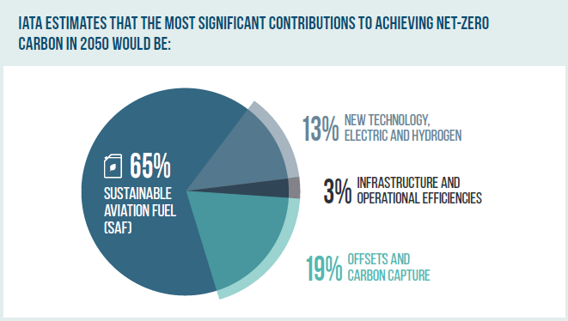

Figure 11 Estimation on net-zero carbon by 2050, according to the RSB report.

Additionally, the alternative fuel types listed is:

* Sustainable Aviation Fuel (SAF).
* Ethanol derived from sugarcane.
* Synthetic aviation and biofuels from solid biomass, including alien invasive plants (AIPs), forest and agricultural residue, and industrial waste.
* Green hydrogen.

### 5.What Global airlines make use of SAF and how can we implement this in South Africa?

According to skynrg.com, 3 major airlines which are listed is: LOT Polish Airlines, Finnair and Corendon, which make use of SkyNrg’s implementation of SAF. The COO of LOT, sees the agreement as “proof in which airlines are striving to reduce the environmental impacts of flight operations.”

Moreover, it is beneficial and encouraged by the SVP of Finnair to “help on this journey of being carbon neutral by 2050.” But then comes the question on how we can implement such SAF in South Africa. In some of the further questions, it is discussed on the way forward, however, here are some ways in which we can implement this in South Africa:

* Establishing regulatory frameworks to incentivize SAF production.
* Investing in research and development for SAF production technologies.
* Collaborating with international partners to share knowledge and resources.
* Providing financial support and subsidies for SAF infrastructure development.
* Encouraging airlines to adopt SAF through policy measures and awareness campaigns.

These are yet to be discussed in further detail.

### 6. What challenges lie ahead for South African airlines in going green, how do they tackle them?

South African airlines face numerous challenges in transitioning to sustainable practices, including those associated with Sustainable Aviation Fuel (SAF) production from sugarcane. The viability of SAF production varies depending on factors such as the type of sugarcane cultivation, with irrigated cane having a higher carbon footprint. Creating an enabling regulatory framework is crucial, requiring collaboration with agencies like the Department of Environment, Forestry, and Fisheries (DEFF) and the South African Civil Aviation Authority (SACAA) to support SAF production. Small-scale growers require assistance with essential structures and equipment to ensure occupational health and safety, a challenge that agencies like the Department of Agriculture, Land Reform, and Rural Development (DALRRD) could address. Additionally, administrative support at the farm level is essential, with agencies like the Agricultural Research Council (ARC) offering expertise. Implementing local labour, preferential labour laws, and procurement processes is necessary for promoting local employment and sustainability, supported by agencies like the Department of Labor and the National Treasury. Strengthening impact assessment processes and greenhouse gas reporting requirements, in collaboration with agencies like the Department of Mineral Resources and Energy (DMRE) and the Department of Forestry, Fisheries, and the Environment (DFFE), helps monitor and mitigate environmental impacts effectively. By addressing these challenges collaboratively and proactively, South African airlines can successfully transition to sustainable practices and contribute to a greener aviation industry.

In addition to challenges related to sugarcane, South African airlines face several other obstacles on their path to sustainability. Access to sustainable aviation fuels (SAF) and their affordability pose significant challenges, with limitations in procurement and high costs potentially impeding progress. Infrastructure and technological readiness also require substantial investments, necessitating retrofitting of aircraft and ground facilities. Complex regulatory frameworks and policies, including those surrounding SAF production and emissions standards, can further hinder adoption. Public perception and consumer demand for eco-friendly air travel play a pivotal role, necessitating marketing efforts to promote green initiatives. Additionally, ensuring the sustainability of supply chains for alternative fuels and eco-friendly products remains a priority, requiring collaboration with suppliers and partners. Addressing these challenges requires a concerted effort involving government agencies, industry stakeholders, and civil society to create an enabling environment for sustainable aviation practices in South Africa.

### 7. How does the South African aviation authority manage aircraft noise pollution?

The South African government has stringent regulations in place, such as Section 91.07.16, to manage aircraft noise pollution and ensure compliance with established noise abatement procedures. These regulations prohibit the operation of aircraft in a manner that contravenes the noise abatement procedures set for aerodromes, as well as the mass limitations prescribed in Part 21 or noise certification standards, unless authorized by the competent authority under exceptional circumstances. The aviation authority in South Africa plays a crucial role in enforcing these regulations and managing aircraft noise pollution through various measures, including the implementation of noise abatement procedures at aerodromes and the monitoring of compliance by operators. Additionally, the authority encourages the use of newer aircraft models equipped with quieter engines to mitigate noise pollution. These newer planes often fall under the category of modern commercial aircraft, such as the Airbus A320neo or the Boeing 787 Dreamliner, which feature advanced engine technologies designed to reduce noise emissions during take-off, landing, and flight. By promoting the adoption of quieter aircraft and enforcing noise abatement regulations, the aviation authority aims to minimize the impact of aircraft noise on surrounding communities and ensure sustainable aviation practices in South Africa.

### 8. What investments are being made from sustainable fuels in South Africa?

In South Africa, various investments are being made into sustainable aviation fuels (SAF) to incentivize industries and foster the development of a green aviation sector. The government is exploring different approaches, including neutral incentives and tax incentives, to encourage investment in SAF production. Additionally, there's a focus on promoting the uptake of green hydrogen, with incentives being linked to the product's environmental benefits. Airlines are encouraged to view investment in SAF as essential for their sustainability and as part of their commitment to being environmentally responsible businesses. However, there's a recognized need for a shift in attitudes among both airlines and consumers regarding the potential cost and price increases associated with SAF. The government is also considering redirecting funds to support or subsidize private sector interventions aimed at developing the biofuel market, with specific funding opportunities available through the Department of Innovation's Industry and Environment Directorate. Furthermore, there's a call for multi-departmental task forces to support biofuel production and efforts to ensure sufficient fuel remains available for local use while navigating blending mandates and incentivizing compliance among local airlines. Through these measures and investments, South Africa aims to foster the growth of a sustainable aviation industry and reduce its carbon footprint.

### 9. How can South African airports reduce their carbon footprint?

Here are some ways in which South African airports can reduce their carbon footprints instead of being in the air, but now on the ground:

* Investing in Renewable Energy: ACSA can install solar panels and wind turbines to generate renewable energy for airport operations. By utilizing clean energy sources, airports can reduce reliance on fossil fuels and lower carbon emissions.
* Energy-Efficient Systems: ACSA can upgrade airport facilities with energy-efficient lighting, heating, ventilation, and air conditioning (HVAC) systems. By optimizing energy usage, airports can minimize carbon emissions associated with electricity consumption.
* Optimizing Ground Transportation: ACSA can collaborate with local transportation authorities to promote public transit, ridesharing, and electric vehicle usage for passengers and employees commuting to and from the airport. By encouraging sustainable transportation options, airports can reduce carbon emissions from ground vehicles.
* Promoting Sustainable Aviation Practices: ACSA can incentivize airlines to use more fuel-efficient aircraft and implement eco-friendly ground procedures, such as minimizing taxiing and idling time. By partnering with airlines and supporting sustainable aviation initiatives, airports can mitigate carbon emissions from aircraft operations.
* Waste Reduction and Recycling: ACSA can implement waste reduction and recycling programs at airport terminals and facilities. By diverting waste from landfills through recycling and composting, airports can minimize carbon emissions associated with waste management.
* Water Conservation: ACSA can implement water-saving measures such as installing water-efficient fixtures and implementing water reuse systems. By reducing water consumption, airports can lower energy usage for water treatment and pumping, consequently reducing carbon emissions.
* Adopting Green Building Practices: ACSA can incorporate green building practices in the design and construction of airport infrastructure, such as using sustainable materials and optimizing energy performance. By constructing energy-efficient buildings, airports can minimize operational carbon emissions.
* Engaging Stakeholders: ACSA can collaborate with airport tenants, airlines, government agencies, and local communities to promote environmental sustainability. By fostering partnerships and stakeholder engagement, airports can implement comprehensive sustainability initiatives that address carbon emissions across the aviation ecosystem.
* Participating in Carbon Offset Programs: ACSA can participate in carbon offset programs or invest in carbon offset projects to compensate for unavoidable emissions. By funding projects that reduce greenhouse gas emissions elsewhere, airports can offset their own carbon footprint.
* Monitoring and Reporting Emissions: ACSA can regularly monitor and report carbon emissions from airport operations, including energy consumption, transportation, waste management, and other activities. By tracking emissions data, airports can identify areas for improvement and measure progress towards carbon reduction goals.

### 10. What green job opportunities are available in South African aviation, what are the requirements needed?

According to the RSB report these green jobs include:

* Sustainable Aviation Fuel (SAF) Production: Jobs related to the production, processing, and distribution of SAF are becoming increasingly relevant. This includes roles in biofuel production facilities, research and development, quality control, and logistics management. According to the report,” The report also estimates that this shift could generate up to 14 million jobs in SAF production worldwide. In Africa, the energy transition would result in approximately 2 million jobs.”
* Renewable Energy Integration: With a focus on transitioning to cleaner energy sources, there are opportunities for professionals skilled in renewable energy technologies. This may involve roles in solar power installation, wind energy management, and other renewable energy integration projects at airports and aviation facilities.
* Environmental Management and Compliance: As sustainability regulations become more stringent, there is a growing demand for environmental management professionals within the aviation industry. These roles involve ensuring compliance with environmental regulations, conducting environmental impact assessments, and implementing sustainability initiatives.
* Sustainable Infrastructure Development: Green job opportunities also exist in the planning, design, and construction of sustainable aviation infrastructure. This includes projects focused on energy-efficient terminals, eco-friendly aircraft hangars, and green building initiatives.
* Carbon Offsetting and Emissions Reduction: Jobs related to carbon offsetting programs, emissions trading, and carbon footprint analysis are emerging as airlines seek to mitigate their environmental impact. Professionals in this field may work for airlines, consulting firms, or environmental organizations.

However, some of these opportunities have requirements which include:

* Relevant academic qualifications, such as a tertiary degree; in environmental science, engineering, renewable energy, sustainability, or related fields.
* Experience or expertise in sustainable aviation practices, renewable energy technologies, environmental management systems, or carbon accounting.
* Knowledge of relevant regulations and standards governing environmental sustainability in aviation.
* Strong analytical skills and the ability to assess environmental impacts and develop mitigation strategies.
* Excellent communication and interpersonal skills to engage stakeholders and promote sustainability initiatives.
* Project management skills to oversee green initiatives from planning to implementation.

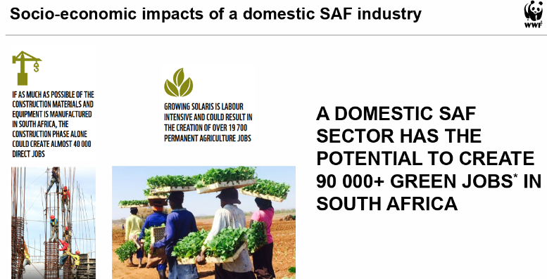

Figure 12 Socio- economic impacts from the domestic SAF industry.

* Commitment to environmental stewardship and a passion for driving positive change in the aviation industry.

# Findings

## Claim 1; Invest in Sustainable Aviation Fuels (SAF’S)

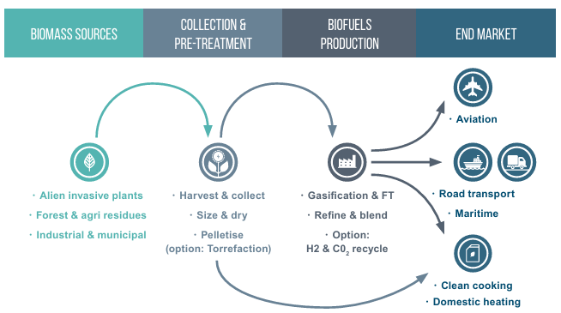As already discussed in the report, investing in Sustainable Aviation Fuels, a cornerstone in reducing the carbon footprint in aviation, will not just provide job opportunities, but also cut down on harmful greenhouse gas emissions. As already mentioned, SAF is fully produced by renewable biomass and waste resources, offering a cleaner alternative to traditional jet fuels.

* Research and development

**Explanation:** By investing in R&D, South Africa can develop proprietary SAF technologies that utilise local biomass and waste materials, reducing dependency on imported fuels. This investment can also lead to breakthroughs in efficiency and cost-effectiveness, making SAF more viable for widespread use.

* Infrastructure Development:

**Explanation:** Building infrastructure for the production, storage, and distribution of SAF is crucial. This includes establishing refineries, storage facilities, and fuelling stations at airports. Adequate infrastructure ensures a steady supply of SAF, encouraging airlines to adopt it more readily.

* Partnerships:

**Explanation:** Collaboration with international organisations, research institutions, and local companies can accelerate SAF development and adoption. Partnerships can bring in expertise, funding, and technology transfer, fostering a supportive ecosystem for SAF innovation.

* Policy Support:

**Explanation:** Government policies can provide the necessary incentives for SAF adoption. Subsidies, tax breaks, and grants can reduce the financial burden on airlines and fuel producers. Regulatory support, such as mandates for SAF usage, can drive demand and ensure compliance with sustainability goals.

## Claim 2; Enhance Aircraft Efficiency

Improving aircraft efficiency can lead to significant reductions in fuel consumption and emissions. Technological advancements can make aviation more sustainable by optimising aircraft performance.

* Fleet Modernisation:

**Explanation:** Encouraging airlines to upgrade their fleets to newer models equipped with fuel-efficient engines can greatly reduce emissions. Modern aircraft designs incorporate advanced aerodynamics, lightweight materials, and more efficient engines, leading to lower fuel consumption per flight.

* R&D Investment:

**Explanation:** Supporting research into new technologies such as electric and hybrid-electric propulsion systems can pave the way for a more sustainable aviation future. Investment in lightweight composite materials can reduce the overall weight of aircraft, leading to improved fuel efficiency.

* Maintenance and Retrofits:

**Explanation:** Regular maintenance and retrofitting of existing aircraft with newer, more efficient technologies can extend their lifespan and improve performance. Upgrades such as winglets, engine modifications, and improved avionics can reduce fuel consumption and emissions.

* Collaboration with Manufacturers:

**Explanation:** Working closely with aircraft manufacturers allows for the integration of the latest technologies into the South African aviation market. This collaboration can help airlines access cutting-edge solutions tailored to their specific needs, enhancing overall fleet efficiency.

## Claim 3; Developing a Comprehensive Green Jobs Strategy

A comprehensive green jobs strategy ensures that the workforce is prepared for the transition to a sustainable aviation industry. It promotes economic stability and growth by creating new employment opportunities in emerging green sectors.

* Training and Education:

**Explanation:** Establishing educational programs and training initiatives focused on sustainable aviation practices can equip current and future professionals with the necessary skills. This can include technical training on SAF production, aircraft maintenance, and environmental compliance, ensuring a skilled workforce for the green aviation sector.

* Job Creation:

**Explanation:** Identifying and creating new roles within the industry that focus on sustainability can drive job growth. Examples include positions in SAF production, environmental monitoring, aircraft retrofitting, and energy management. These jobs contribute to reducing the industry's environmental impact while providing employment opportunities.

* Support for SMEs:

**Explanation:** Encouraging the growth of SMEs specializing in green technologies and services can spur innovation and job creation. Providing financial and technical support to these enterprises can help them scale their operations, contributing to a vibrant and sustainable aviation ecosystem.

* Policy and Incentives:

**Explanation:** Developing policies that support green job creation can facilitate the transition to a sustainable aviation industry. This includes grants for green projects, tax incentives for companies adopting sustainable practices, and subsidies for green businesses. These measures can attract investment and encourage the growth of a green workforce.

# Conclusion

After extensive research and thorough discussions, it is clear that the South African aviation industry stands on the brink of a transformative shift toward sustainability. Our survey, which gathered insights from 30 individuals, revealed that approximately 60% are enthusiastic about the integration of green jobs, whether as mechanics, engineers, or other roles focused on environmental sustainability. This positive sentiment highlights a readiness to embrace change and innovate within the industry.

Moreover, the adoption of Sustainable Aviation Fuels (SAF) emerges as a critical strategy in this green transition. By reducing greenhouse gas emissions, SAF will play a pivotal role in mitigating the environmental impact of aviation in South African skies.

This dual focus on green job creation and sustainable fuels not only aligns with global sustainability goals but also ensures the long-term viability and resilience of the South African aviation industry. By investing in SAF technologies, enhancing aircraft efficiency, and developing comprehensive green job strategies, the industry can support the creation of new employment opportunities while fostering a skilled workforce prepared for the demands of a greener future.

Through collaborative partnerships, policy support, and continuous innovation, the South African aviation sector can achieve a harmonious balance between technological advancement and environmental stewardship, securing a sustainable future for generations to come.

# Bibliography

Authority, S. A. (2012, June` 12). Air Laws. Johannesburg, Gauteng, South Africa: Governmental.

Chireshe, F. (2023). *A blueprint for Sustainable Aviation Fuel (SAF) production in South Africa.* Stellenbosch: WWF South Africa. Retrieved March 10, 2024, from https://www.wwf.org.za/our_work/initiatives/sustainable_aviation_fuel/

RSB. (2022). *Sustainable Aviation Fuel in SA.* Vernier: RSB. Retrieved March 10, 2024, from https://rsb.org

Shrives, L., Simpson, A., & Ryder, H. (2017). *Environmental Noise Impact: Baseline Assessment & Impact Prediction - Pietermaritzburg Airport.* Institute of Natural Resources NPC. Pietermaritzbutg: IMA Trader 20 cc. Retrieved March 10, 2024

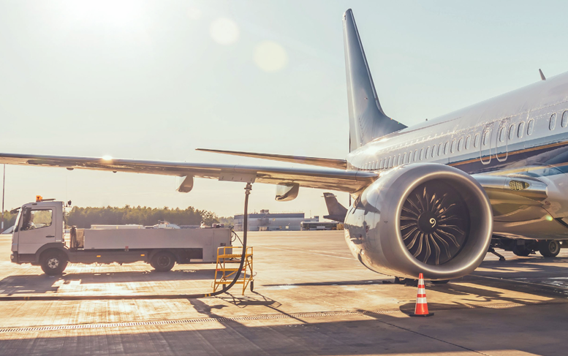

Figure 6 Image of greener fuel loaded into plane (Boeing 737)

# Appendix A: Table

| No. | Question | Question Level (1,2,3,4) | Category | Type of  Source | Bibliographical information | | Quality of Information found | | Summary of Information found |
| --- | --- | --- | --- | --- | --- | --- | --- | --- | --- |
| 1 | What are the current aviation emissions in South Africa, and how do they compare to other sectors? | 4 | Problem | Website | **Authors(s)** | SAA | **Authority** | Author is an employee at the company and served many years within it | Hyperlink for Q1 |
| **Name of Website** | Flysaa.com | **Currency** | 2020 and is still relevant |
| **Date created** | 2020 | **Accuracy** | Corresponds with related sources and is accurate |
| **Date accessed** | 01 March 2024 | **Objectivity** | factual |
| **URL** | [www.flysaa.com](https://ujac-my.sharepoint.com/personal/shaunl_uj_ac_za/Documents/www.flysaa.com) | **Coverage** | Provides reasons for development |
| 2 | How do South African airlines and airports use renewable energy, what’s the percentage of their energy consumption from this? | 3 | Background | Report | **Authors(s)** | Roundtable on Sustainable Biomaterials Association | **Authority** | Employees at the company, spent many years, developing strategies | Hyperlink for Q2 |
| **Name of Website** | RSB | **Currency** | 2022, still current |
| **Date created** | 21 April 2022 | **Accuracy** | Answers question |
| **Date accessed** | 01 March 2024 | **Objectivity** | Factual |
| **URL** | [www.rsb.org](https://ujac-my.sharepoint.com/personal/shaunl_uj_ac_za/Documents/www.rsb.org) | **Coverage** | Variety of solutions |
| 3 | What governmental policies drive environmental practices in South Africa? | 4 | Background | Government Report | **Authors(s)** | South African Civil Aviation Authority | **Authority** | Employee | Hyperlink for Q3 |
| **Name of Website** | SA Government | **Currency** | 2020 |
| **Date created** | 20 March 2020 | **Accuracy** | Recent |
| **Date accessed** | 01 March 2024 | **Objectivity** | Factual |
| **URL** | [www.gov.za](https://ujac-my.sharepoint.com/personal/shaunl_uj_ac_za/Documents/www.gov.za) | **Coverage** | Wide variety of options |
| 4 | How will South African airlines integrate fuel-efficiency into their fleets? | 3 | Solution | Report | **Authors(s)** | Roundtable on Sustainable Biomaterials | **Authority** | Employees at the company, spent many years, developing strategies | Hyperlink for Q4 |
| **Name of Website** | RSB | **Currency** | 2022, still current |
| **Date created** | 21 April 2022 | **Accuracy** | Answers question |
| **Date accessed** | 01 March 2024 | **Objectivity** | Factual |
| **URL** | [www.rsb.org](https://ujac-my.sharepoint.com/personal/shaunl_uj_ac_za/Documents/www.rsb.org) | **Coverage** | Employees at the company, spent many years, developing strategies |
| 5 | What Global airlines make use of SAF and how can we implement this in South Africa? | 4 | Background | News Article | **Authors(s)** | Jez Lowe | **Authority** | Employee | Hyperlink for Q5 |
| **Name of Website/Web Page** | SkyNrg, Airlines with SAF +Jobs | **Currency** | 2023, current |
| **Date created** | 2023 | **Accuracy** | Corresponds |
| **Date accessed** | 01 March 2024 | **Objectivity** | Factual |
| **URL** | [www.skynrg.com](http://www.skynrg.com) | **Coverage** | options |
| 6 | What challenges lie ahead for South African airlines in going green, how do they tackle them? | 4 | Consequences | Report | **Authors(s)** | RSB | **Authority** | Employees at the company, spent many years, developing strategies | Hyperlink for Q6 |
| **Title** | SAF Report | **Currency** | 2022, still current |
| **Date published** | 21 April 2022 | **Accuracy** | Answers question |
| **Publisher** | RSB | **Objectivity** | Factual |
|  |  | **Coverage** | Employees at the company, spent many years, developing strategies |
| 7 | How does the South African aviation authority manage aircraft noise pollution? | 3 | Background | Government Report | **Authors(s)** | SACAA | **Authority** | Government | Hyperlink for Q7 |
| **Title** | Noise abatement report | **Currency** | 2012, but still current |
| **Date published** | 1 June 2012 | **Accuracy** | Corresponds |
| **Publisher** | SA government | **Objectivity** | Factual |
|  |  | **Coverage** | Options |
| 8 | What investments are being made from sustainable fuels in South Africa? | 4 | Background | Report | **Authors(s)** | RSB | **Authority** | Employees at the company, spent many years, developing strategies | Hyperlink for Q8 |
| **Title** | SAF Report | **Currency** | 2022, still current |
| **Date published** | 21 April 2022 | **Accuracy** | Answers question |
| **Publisher** | SAF | **Objectivity** | Factual |
|  |  | **Coverage** | Employees at the company, spent many years, developing strategies |
| 9 | How can South African airports reduce their carbon footprint? | 4 | Solution | Website | **Authors(s)** | Tulisiwe Mkatshwa | **Authority** | Employee | Hyperlink for Q9 |
| **Title** | Airport Company South Africa launches solar power plant | **Currency** | 2016, still current |
| **Date published** | 2016 | **Accuracy** | Accurate |
| **Publisher** | ACSA | **Objectivity** | Factual |
| **URL** | [www.airports.co.za](http://www.airports.co.za) | **Coverage** | Options |
| 10 | What green job opportunities are available in South African aviation, what are the requirements needed? | 3 | Solution | News Article | **Authors(s)** | Schalk Burger | **Authority** | Investor, lots of activities | Hyperlink for Q10 |
| **Title** | Sustainable aviation fuels can be a potential green industry in South Africa | **Currency** | 2022 |
| **Date published** | 10 June 2022 | **Accuracy** | Corresponds |
| **Publisher** | Engineering news.co.za | **Objectivity** | Factual |
| **URL** | [Sustainable aviation fuels can be a potential green industry in South Africa (engineeringnews.co.za)](https://www.engineeringnews.co.za/article/sustainable-aviation-fuels-can-be-a-potential-green-industry-in-south-africa-2022-06-10) | **Coverage** | Wide variety of Information |

A

ACSA

Airports Company of South Africa 18, 19

AIP

Alien Invasive Plants 14

ARC

Agricultural Research Council 16

C

CO2

Carbon Dioxide 3, 9, 10

COO

Chief Operating Officer 15

D

DALRRD

Department of Agriculture, Land Reform, and Rural Development 16

DEFF

Department of Environment, Forestry and Fisheries 16

DMRE

Department of Mineral Resources and Energy 16

E

EIA

Environmental Impact Assessment 13

H

HEFA

Hydro processed Esters and Fatty Acids 11

HVAC

Heating, Ventilation and Air Conditioning 18

I

IEnvA

Internation Air Transport Association Environmental Assessment 9

N

NEMA

National Environmental Management Act 11

R

REIPPPP

Renewable Energy Independant Power Producer Procurement Programme 12

RSB

Roundtable on Sustainable Biomaterials 10, 13, 19, 26, 27, 28

S

SAA

South African Airlines 9, 10, 25

SACAA

South African Civil Aviation Authority 16, 28

SAF

Sustainable Aviaton Fuel 10, 11, 14, 15, 16, 17, 20, 27, 28

SASSI

Southern African Sustainable Seafood Initiative 10

SSA

Sub- Saharan Africa 11

W

WWF-SA

World Wildlfe Fund- South Africa 10

# Appendix C: Authenticity

